

**SQE ASSIGNMENT NO :2**

**SUBMITTED TO : SIR MUHAMMAD KAMRAN**

**SUBMITTED BY : ABUBAKKER HASHMI**

**REG NO: 13**

CPMS (SQE ASSIGNMENT)

# TABLE OF CONTENT pg #n

# 1 INTRODUCTION 2

* 1. BACK GROUND STUDY 3
  2. PROBLEM STATEMENT
  3. SCOPE OF STUDY 3
  4. VISON 4

# 3 REQUIRMENTS

3.1 FUNCTIONAL 5

3.2 NON FUNCTIONAL 6

# 4 DESIGN

4.1 USE CASE 7

4.2 ACTIVITY 8

4.3 CLASS 16

4.4 SEQUENCE 17

# 5 IMPLEMENTATION

5.1 GUI 18

5.2 CONCLUSION 20

Car parking management system

**Introduction :**

This document is a proposal for the design and development of a  
Vehicle Parking management system. . This is designed to maintain a  
good record of vehicles check in and checkout time. Both two wheeler  
& four wheeler can be managed by this system and have different  
pricing system .The system will comprise of two stand by PC to maintain record of  
vehicle while entering and exiting.

**BACKGROUND OF STUDY**This chapter discusses on the introduction of study. It represents the overview  
of the study and briefly explains the background, the aim, problem statement, research  
question, research objectives, scope of study, significant of proposed research and  
expected outcomes from this research.  
Basically, any building development and construction must consider space for  
parking lots. People need proper car parks to be provided to them inside or outside the  
building especially the building operates at 24 hours. If the parking area is not in the  
development consideration, then the project can be considered as failure.  
These changes also cause impact to the modem technologiáal system which  
becomes more sophisticated. The same goes to the advancement of modem  
transportation. Because of this, demand for modem motor vehicles increases  
especially cars. The use of motor vehicles especially cars creates a few problems, for  
example, congested traffic. And the worse problem that exist today is the parking space  
or parking facilities. Many problems arise because of this matter.  
In this research, we must know the actual problem, the existing facilities is  
suitable or not, effect on traffic and also effect on the environment should considered  
in this marking parking problem. Besides that, research on stopping car also important  
because the car drive slowly to find parking place. There are several method will be  
made according to the type and volume size or research area. From this research, we  
can imagine the real situation of available car parking system or the new available car  
parking. From this data, we can get the provision of parking policy and control the  
placement of parking needed.  
The parking space provided by the road side has actually decreased the  
effectiveness of the road system. Therefore a research in facilitating this parking issues  
is highly recommended to foresee the needs and demands of this facilities. In short,  
this research is conducted to analyses the available parking space and facilities, as  
whether they are sufficient, comfortable and safe more than *85%* in developing  
countries

**Problem statement:**

The system we are going to resign unfortunately doesn't exist in our country  subsystem easiest in New York commerce automatic car parking machine the current manual system has many problems some of them  are as follows

1. manual system is slow and time consuming.
2. not so much efficient
3. it is not intractable
4. unfamiliar personal can't able to use it
5. there is a lot of space problem as  two owner 12 or replace so mainly they miss behave with each other.

**MORE :**Parking plays an important role in mobility, access and the economic  
development of cities at the same time, it is a profitable business for both the private  
and public sectors. The car parking market is a sector of the economy that has increased  
in importance as the market for cars has grown. Cars have become a fundamental  
element ofjourney mobility and, in consequence, parking has as well. The car-parking  
sector has always been of great importance in terms of urban mobility, since it is a  
fundamental element in achieving a high level of accessibility in the city centers. In  
fact, many businesses and municipalities see an adequate supply of parking, especially  
for visitors, as crucial for their competitive growth.  
As the number of cars increases, with no initiatives and alternatives to combat  
the current scenario, many problems arise especially to the limited number of parking  
lot. This can give a significant effect, especially to commercial property. Parking  
issues come from the public behavior itself. The public come to the market and simply  
park their vehicle anywhere and everywhere they like:

**SCOPE OF STUDY**

The objective of this project is to build a Vehicle Parking management  
system that enables the time management and control of vehicles  
using number plate recognition. The system that will track the entry  
and exit of cars, maintain a listing of cars within the parking lot, and  
determine if the parking lot is full or not. It will determine the cost of  
per vehicle according to their time consumption

The study is limited to scope and limitation, in order to receive a clear result  
from the analysis. The scope of the study will focus on:  
 The issues are to see the  
supply and demand parking space provided.  
To achieve the aim of this study, that is to assess the parking parameter form  
data available. Then followed by some conclusions and recommendations to  
the topic.  
This study depends very much on primary and secondary data. Therefore, the  
nature of this study is more of a critical review on the time management, and  
to investigate the system and process of managing parking space.

**Vision :**

* To facilitate the people
* Improve security measures
* Less space consumption
* Use of latest technology

This paper describes an approach to overcome a situation of monitoring and managing a parking area using a vision based automated parking system. With the rapid increase of cars the need to find available parking space in the most efficient manner, to avoid traffic congestion in a parking area, is becoming a necessity in car park management. Current car park management is dependent on either human personnel keeping track of the available car park spaces or a sensor based system that monitors the availability of each car park space or the overall number of available car park spaces. In both situations, the information available was only the total number of car park spaces available and not the actual location available. In addition, the installation and maintenance cost of a sensor based system is dependent on the number of sensors used in a car park. This paper shows a vision based system that is able to detect and indicate the available parking spaces in a car park. The methods utilized to detect available car park spaces were based on coordinates to indicate the regions of interest and a car classifier. This paper shows that the initial work done here has an accuracy that ranges from 90% to 100% for a 4 space car park. The work done indicated that the application of a vision based car park management system would be able to detect and indicate the available car park spaces LESS

Chap 3 requirements

# Functional requirements:

* **Sign in :**

The user and admin will create the account at start,finger print ,credit card number and other necessary information will be stored at this phase,

* **Approval :**

The system will check the capacity at first than it will the park car else the system will reject the request.

* **Car parking :**

After approvel the hydraulic lifter will park the car at stated location , by a 3D map.

* **Payment:**

Payment will be received via munually ort horugh credit card.

* **Car ejecting:**

After all the clearance the system will eject the car.

# Non functional requirements:

**Paper Records:**

It is difficult to sieve through the large volumes of information. For accomplishing this task, the parking lot managers have to spend hours searching files for the exact information. So, these paper records create a lot of problems.

**Manual Checks:**

Parking managers perform manually intensive work of counting permit and non-permit cars. There is manual checking of vehicle status and details and handwritten tickets. Such a manual procedure leads to 5% entry errors, further resulting in huge losses to the bottom line.

**High Labor Costs:**

Reading, writing and entering data is labor-intensive and time consuming. Unnecessary capital expenditure is increased due to the money spent on labor that performs repetitive manual tasks.

**Waiting Customers:**

he outdated mode of management troubles the customers and makes them wait in long queues when they need to enter and exit the parking lot. Due to this, precious time of the clients is wasted, and their sustainability gets shaken.

**Unauthorized Access:**

The parking manager in-charge issue handwritten paper tickets that can be duplicated easily. No security alerts are raised to the authorized personnel if any unauthorized vehicle enters the parking lot

**Security Alarms and Alerts:**

With customized parking space management, parking lot owners can forget unauthorized access of vehicles. Security alerts are raised in real-time and delivered by e-mail or text message to appropriate personnel. RFID technology in parking management solutions is the most secure medium than other networks to perform parking control operations.

**Reduce Labor Costs:**

Auto system is fully automatic, and there’s really not much to do after employing the same. It requires limited personnel to be kept for performing various parking operations. It’s almost like unmanned 24-hour operation. Hence, costs with wireless RFID system are greatly reduced.

Chapter 4 Design

Use case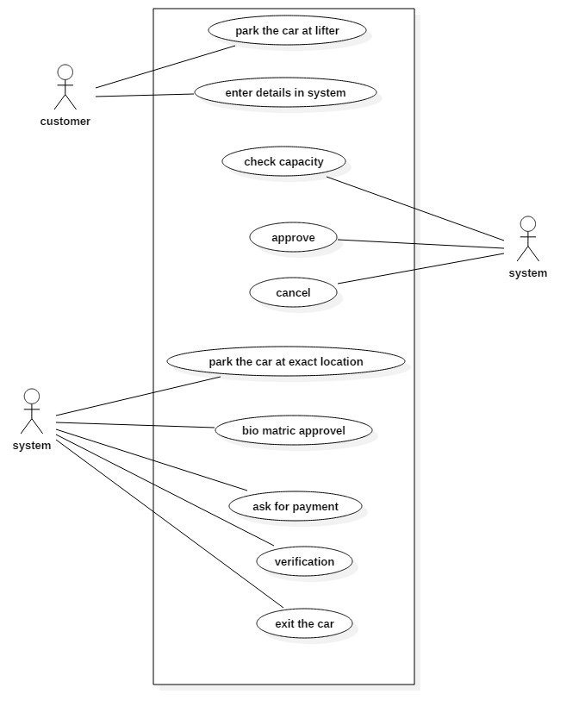

# Activity diagram:

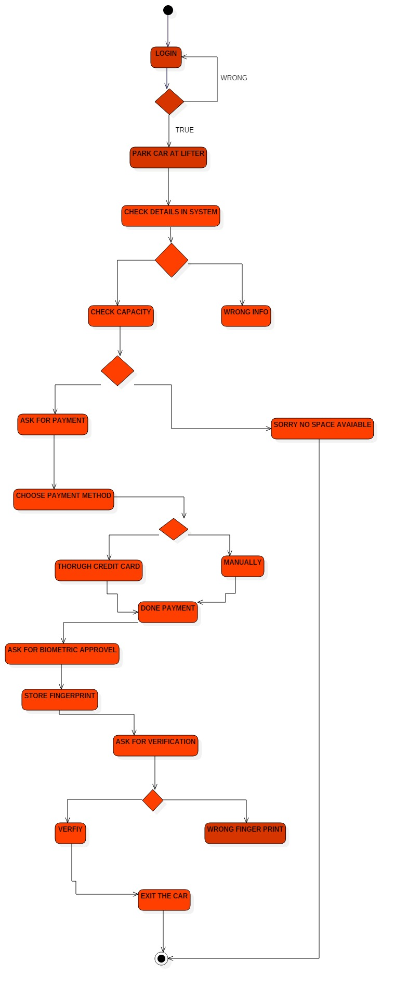

Use case based :

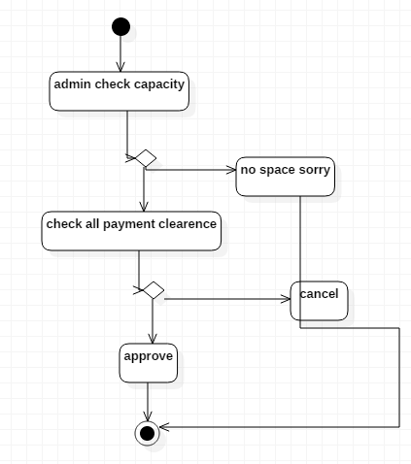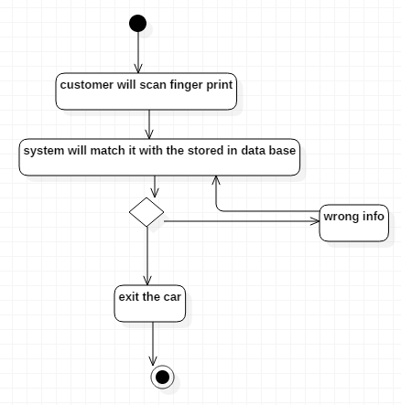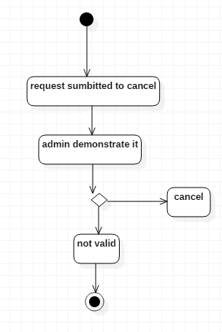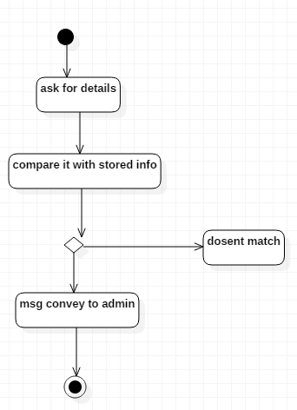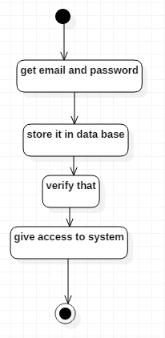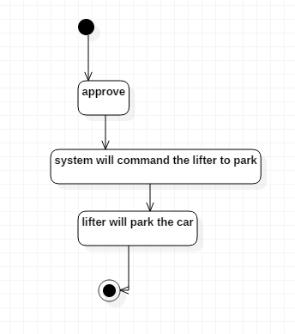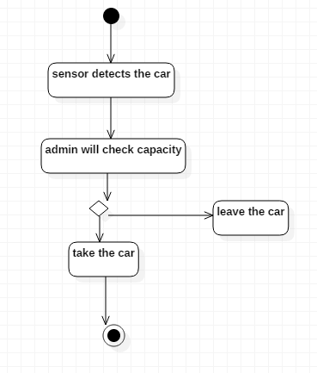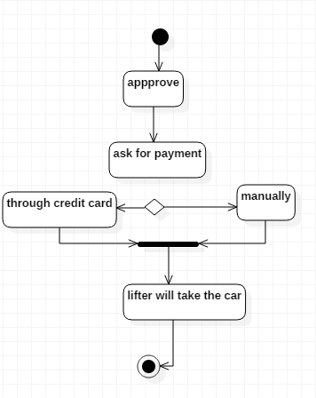

# Class diagram:

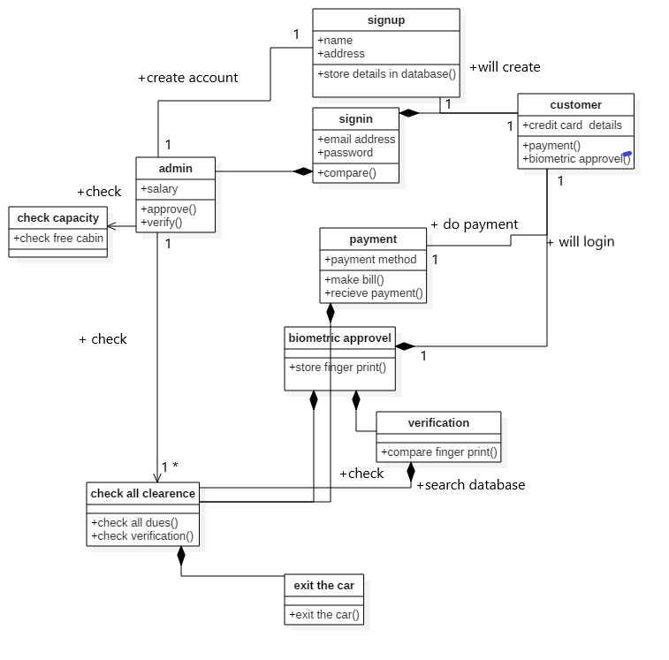

# Sequence diagram:

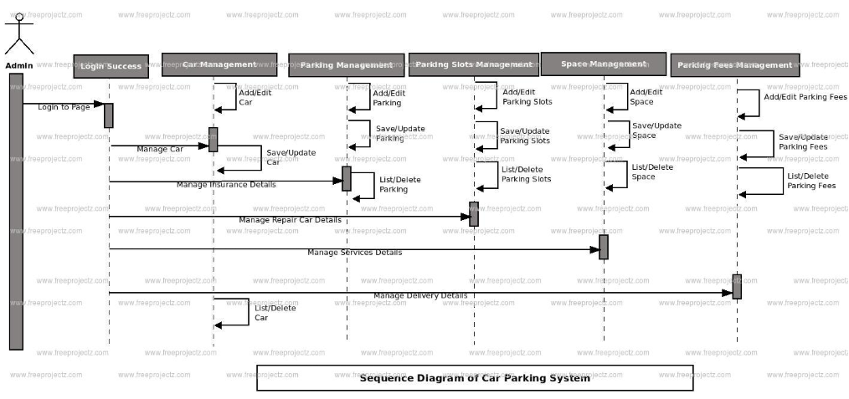

Chapter 5 implementation:

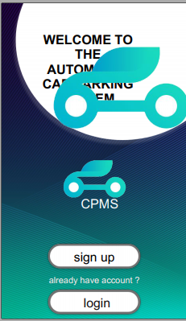

: 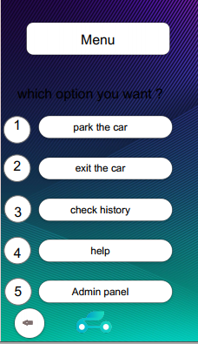

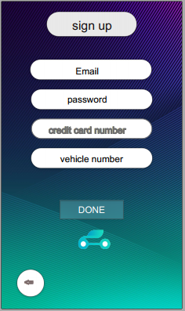

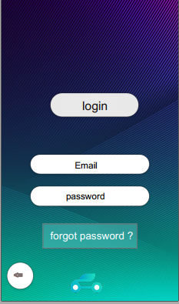

# Gui -------------->>>

Conclusion:

Over all we provide the maximum ease and relaxation, the system will provide high efficiency and usability for both nature and human being .

The system will

* Response actively
* High secure
* Advance
* Robust
* Easy to use
* Fast to respond
* Consistent and convenient
* Clean
* The final project has shown great effect and reduce the environment pollution
* Avoid the land pollution with crude and engine oil.
* The final product was active tor ran off the rain
* Customer was much satisfied with this than the previous one.
* Easy and effective to use.

So that is the final project :)

# Thnx !